Login Validation

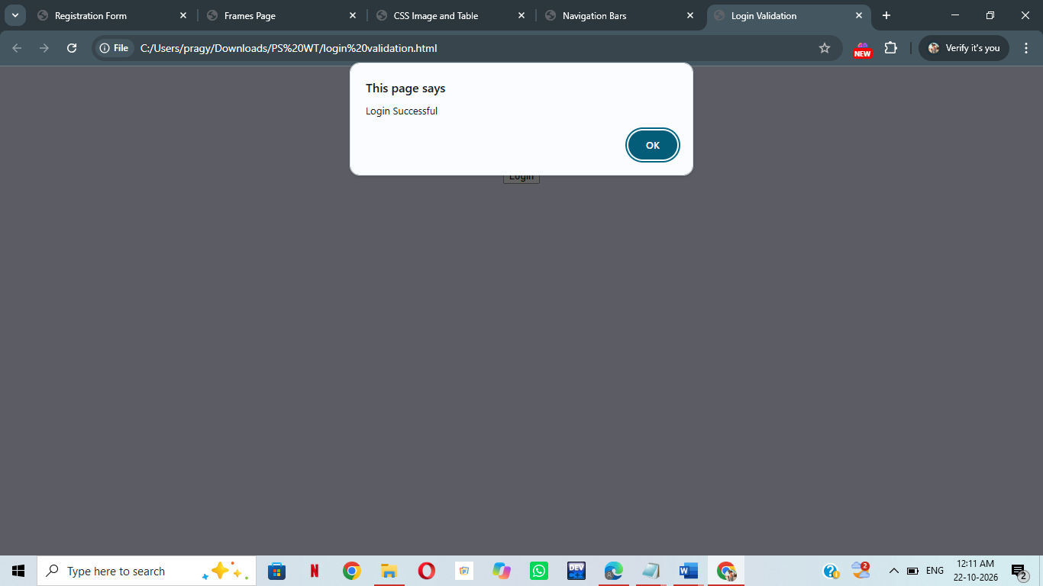

<html>
<head>
<title>Login Validation</title>
</head>
<body bgcolor="lavender" >
<h2 align="center">Login Form</h2>
<form onsubmit="return validateLogin()" align="center">
Username:
<input type="text" id="username">
<br><br>
Password:
<input type="password" id="password">
<br><br>
<input type="submit" value="Login">
</form>
<script>
function validateLogin() {
let username = document.getElementById("username").value;
let password = document.getElementById("password").value;
if (username.trim() === "") {
alert("Please enter username");
return false;
}
if (password.trim() === "") {
alert("Please enter password");
return false;
}
if (username === "admin" && password === "1234") {
alert("Login Successful");
return true;
}
alert("Invalid Username & Password");
return false;
}
</script>
</body>
</html>

